190905104
Parth Shukla
Lab 8

Deadlock, Locking, Synchronising

1) Modify the above Producer-Consumer program so that, a producer can produce at the most 10 items more than what the consumer has consumed.

#include <stdio.h>
#include <stdlib.h>
#include <pthread.h>
#include <semaphore.h>

int buf[10], f, r;
sem_t mutex, full, empty;

void* produce(void* arg){
for(int i=0; i < 10; i++){
sem_wait(&empty);
sem_wait(&mutex);

printf("Produced item is %d\n", i);

buf[(++r) % 10] = i;
sleep(1);

sem_post(&mutex);
sem_post(&full);
// printf("full %u\n", full);
}
}

void* consume(void* arg){
int item;

for(int i = 0; i<10; i++){
sem_wait(&full);
// printf("full %u\n", full);

sem_wait(&mutex);
item = buf[(++f) % 10];

printf("Consumed item is %d\n", item);
sleep(1);

sem_post(&mutex);
sem_post(&empty);
}
}

int main(){
pthread_t t1, t2;
sem_init(&mutex, 0, 1);
sem_init(&full, 0, 1);
sem_init(&empty, 0, 10);
pthread_create(&t1, NULL, produce, NULL);
pthread_create(&t2, NULL, consume, NULL);
pthread_join(t1, NULL);
pthread_join(t2, NULL);
}

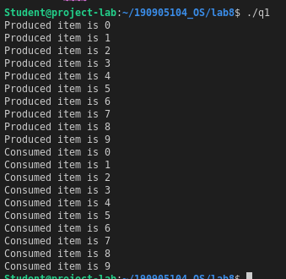

2) Write a C program for the first readers-writers problem using semaphores.

#include <pthread.h>
#include <semaphore.h>
#include <stdio.h>

sem_t wrt;
pthread_mutex_t mutex;
int count = 1;
int numreader = 0;

void *writer(void *wno)
{
sem_wait(&wrt);
count *= 2;
printf("Writer %d modified 'count' to %d\n", (*((int *)wno)), count);
sem_post(&wrt);
}

void *reader(void *rno)
{
pthread_mutex_lock(&mutex);
numreader++;

if(numreader == 1)
sem_wait(&wrt); // first reader will block the writer
pthread_mutex_unlock(&mutex);

// Reading Section, no locks

printf("Reader %d: read 'count' as %d\n",*((int *)rno),count);

// Reader acquire the lock before modifying numreader
pthread_mutex_lock(&mutex);
numreader--;

if(numreader == 0)
sem_post(&wrt); // If this is the last reader, it will wake up the writer.

pthread_mutex_unlock(&mutex);
}

int main()
{
pthread_t read[10],write[5];
pthread_mutex_init(&mutex, NULL);

sem_init(&wrt,0,1);

int a[10] = {1,2,3,4,5,6,7,8,9,10}; //used for numbering the producer and consumer

for(int i = 0; i < 10; i++)
pthread_create(&read[i], NULL, reader, &a[i]);

for(int i = 0; i < 5; i++)
pthread_create(&write[i], NULL, writer, &a[i]);

for(int i = 0; i < 10; i++)
pthread_join(read[i], NULL);
for(int i = 0; i < 5; i++)
pthread_join(write[i], NULL);

pthread_mutex_destroy(&mutex);
sem_destroy(&wrt);
return 0;
}

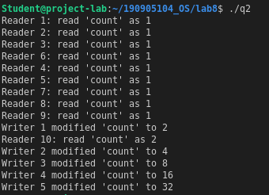

3) Write a Code to access a shared resource which causes deadlock using improper use of semaphore.

#include <pthread.h>
#include <stdio.h>
#include <semaphore.h>

sem_t s1,s2;

void *func1(void *p)
{
// trying to decrement s1
sem_wait(&s1);
// trying to decrement s2
sem_wait(&s2);
printf("Thread 1\n");
// increment s1
sem_post(&s1);
}

void *func2(void *p)
{
// trying to decrement s2, however would not be able to since it is already 0 and is not incremented in func1()
sem_wait(&s2);
// trying to decrement s1
sem_wait(&s1);
printf("Thread 2\n");
// increment s2
sem_post(&s2);
}

int main()
{
pthread_t threads[2];
sem_init(&s1,0,1);
sem_init(&s2,0,1);
pthread_create(&threads[0],0,func1,0);
pthread_create(&threads[1],0,func2,0);
pthread_join(threads[0],0);
pthread_join(threads[1],0);sem_destroy(&s1);
sem_destroy(&s2);
}



4) Write a program using semaphore to demonstrate the working of sleeping barber problem.

#include <stdio.h>
#include <pthread.h>
#include <semaphore.h>
#include <stdlib.h>
#include <unistd.h>

sem_t customer,barber;
pthread_mutex_t seat;
int free1 = 10;

void *barber_(void *args)
{
while(1)
{
// Sleeping
sem_wait(&customer);
// customer is here, so locking the seat
pthread_mutex_lock(&seat);

if(free1<10)
free1++;
sleep(2);

printf("Cutting completed: free seats: %d\n",free1);
// Barber is cutting hair
sem_post(&barber);
// release the chair
pthread_mutex_unlock(&seat);
}
}

void *customer_(void *args)
{
while(1)
{
// Locking seat for customer
pthread_mutex_lock(&seat);

if(free1 > 0)
{
free1--;

printf("Customer waiting: free seats: %d\n",free1);
// Telling barber a seat is free
sem_post(&customer);
// Unlock seat
pthread_mutex_unlock(&seat);
// Waiting if barber is busy
sem_wait(&barber);
}
else // no seat empty, customer leaves
pthread_mutex_unlock(&seat);
}
}

int main()
{
pthread_t threads[2];
sem_init(&barber,0,1);
sem_init(&customer,0,1);
pthread_mutex_init(&seat,0);
pthread_create(&threads[0],NULL,barber_,NULL);
pthread_create(&threads[1],NULL,customer_,NULL);
pthread_join(threads[0],NULL);
pthread_join(threads[1],NULL);
sem_destroy(&barber);
sem_destroy(&customer);
pthread_mutex_destroy(&seat);
}

